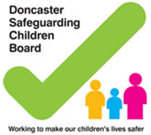

DONCASTER SAFEGUARDING CHILDREN BOARD

MULTI-AGENCY LEVELS OF NEED

September 2017 (Updated November 2017)

Version | Date | Changes Made | Changes Made By
2 | 5.8.15 | Incorporated various comments | Rosie Faulkner
3 | 21.8.15 | Incorporated EH strategy | Rosie Faulkner
4 | 02.09.15 | Incorporated various comments | Deborah Gore
5 | 17.5.16 | Various changes and clarification of terminology regarding the windscreen; SEND and stronger families information added. | Rosie Faulkner / Gemma Roberts
6 | 14.9.17 | Updated to reflect new Early Help Strategy | Rosie Faulkner

1. Introduction
Most children, young people and families have a number of basic needs that can be supported through a range of universal services. These services include Education, Early Years, Health, Housing, Youth Services, leisure facilities and services provided by voluntary organisations. However, some families may have needs which will require additional support at different levels to enable them to reach their full potential.
This document seeks to assist professionals within the children’s workforce to identify suitable responses to identified needs. It also aims to clarify the circumstances which will require referral to a specific agency to address an individual need, when to carry out an early help enquiry and when to refer to Children’s Social Care Services where a child or young person is thought to be at risk of harm, either actual or likely
This document describes:
- The types of need that should be considered at each level and the associated assessment arrangements;
- The criteria for access to services in Doncaster for children, young people and their families and fit with the wider context of multi-agency provision and the range of provision to meet assessed needs;
- The arrangements and threshold for families to be provided with Early Help.
- The legal definition of ‘Children in Need’ and eligibility criteria for Children’s Social Care Services;
- The criteria, process and benefits of identifying families as Stronger Families.
Appendix 1 provides a description of the levels of needs and examples of what indicators might be seen to identify the action required at each level. The descriptions in Appendix 1 provide illustrative examples about how need might present itself, rather than an exhaustive list of fixed criteria that must be met. The level of need may be increased by the interaction of multiple factors. The appendix includes the assessment processes to be followed at each level.
2. Values and Principles
- All services will seek to identify needs as early as possible with the aim of providing relevant services to enable a child or young person to achieve good outcomes in all dimensions of their life;
- Identifying and meeting needs of a child or young person is the shared responsibility of all relevant agencies in the Borough;

- The needs of a child, young person or their family must be determined through robust assessment which will deliver a proportionate service response in a timely way;
- Understanding a child’s or young person’s actual and lived experience is a core part of effective assessment;
- The co-ordination of services and avoiding unnecessary duplication of effort is important in making the best use of valuable resources;
- As far as possible, without prejudicing the safety of a child or young person, parents should be fully engaged in assessment and planning processes;
- Universal services run across all levels and must always be considered even where higher level interventions are necessary.
3. Types of need and service responses (Please see Continuum of Need chart)
Types of need and levels, alongside service responses and processes are set out in the following table and in Appendix 1.
1. Universal services- working to meet basic needs
2. Universal Plus- working alongside universal services to meet a single or need
3. Partnership working - working alongside universal services to meet additional or more complex needs
4. Safeguarding working alongside universal and targeted services to meet the complex and/or multiple needs of a vulnerable child or young person

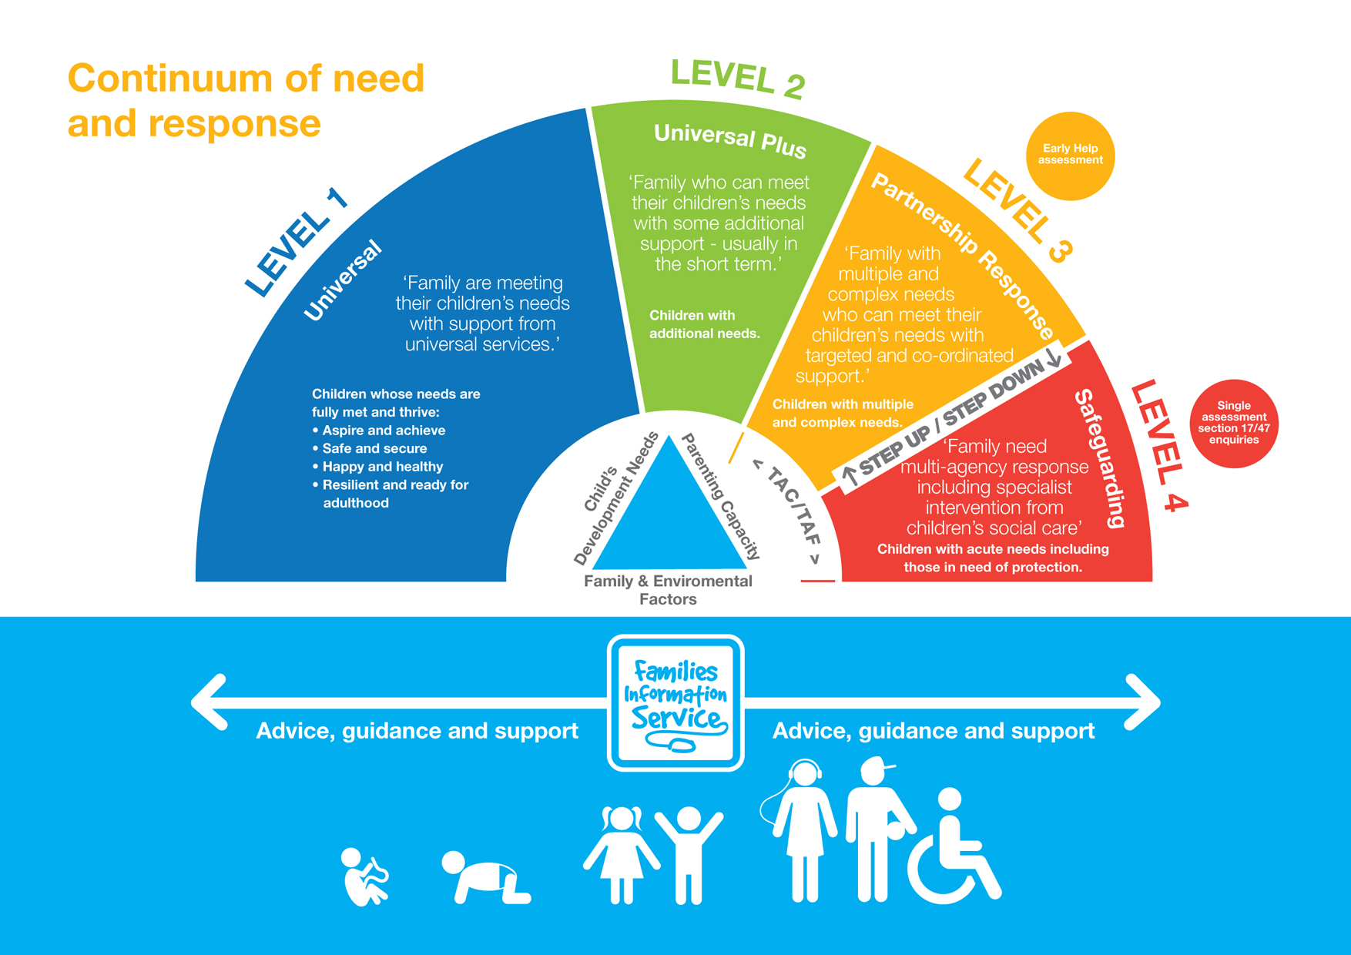

When applying the Continuum of Need to a particular child, young person or family it is important that intervention should be at the lowest level appropriate to meet the needs of the family and prevent the need for escalation to specialist services.
If there are child protection concerns about a child’s or young person’s health or development professionals must follow the Doncaster Safeguarding Children Procedures and make an immediate referral to Doncaster Children’s Services Trust, Referral and Response Team.
If a child or young person has been the subject of child protection or child in need services but the level of need has reduced, consideration must be given to what other help may still be needed to support and sustain progress across all dimensions of a child’s or young person’s life.
4. Over-arching policy framework
The overriding objective in establishing a needs-led process supported by effective assessments and coordinated service provision is to ensure that outcomes for a child or young person not only improve but are sustained. The importance of achieving a sense of permanency for a child or young person is emphasised, ideally within their own family or if not possible within a time scale pertinent to the age of the child or young person, in a substitute family. The notion of permanency, therefore, runs through this document and the criteria for assessing need set out in Appendix 1
5. Levels of Need
The four levels of need identified in the diagram above have been developed into a matrix of needs and risks in Appendix 1. The Appendix describes the circumstances in which an early help enquiry should be considered and when a referral to children’s social care services may be necessary. The levels of need and service responses must be seen as a continuum and not as a barrier to service provision. Progression can be from low to high need levels as well as high need to low depending on the outcome of assessments and good quality evidence of progress against planning aims and objectives in order to promote child wellbeing.
Universal provision, including universal plus, runs across all levels and should not be viewed as an either/or approach. A child, young person and their family are entitled to use universal services although they may have high needs at levels 3 or 4. The objective will be to deliver specialist services in the context of universal provision in order to keep a child or young person safe, to promote their wellbeing in all dimensions and to sustain improvements as part of a step-down agreement, thus reducing re-referral; The Early Help Hub will maintain a record of all Early Help Assessments undertaken to ensure joined up support is offered and enables professionals from different agencies, who may have identified a need, to keep in touch with each other and continue to share relevant information on progress.
Most families’ needs will generally be met by within universal services (level 1). If additional needs arise families are encouraged to access services they feel can assist and such services can be provided in the context of universal–plus. The aim of universal-plus is to enable families to continue to benefit from universal provision with an element of defined support, usually from a single agency and in line with an agreement.
If the need escalates targeted support may be offered at level 2- Universal Plus. This would usually be offered by a single agency approach, but may involve partners where additional needs are identified e.g. a need for Speech and Language Therapists, or need for universal Children Centre services such as Stay and Play sessions). There is unlikely to be a need for a ‘lead practitioner’ to be identified but it may help to understand and record children and young people’s needs if an Early Help Assessment is undertaken. The practitioner who identifies the concerns should make an early help enquiry into the Early Help Hub. The Early Help Hub will then screen the enquiry for further information and make a decision whether there is a need to progress to an Early Help Assessment. Professionals can seek information, advice and guidance for themselves or their family from the Early Help Hub or DMBC Early Help Coordinators.
If the Early Help Hub identifies needs that are continuing or escalating a multi-agency co-ordinated approach may be required, a lead practitioner will be identified by Early Help Hub who will lead the Early Help Assessment and TAC/TAF meeting, that will, with the family develop the plan to address need.
If following multi-disciplinary TAC/TAF support it is concluded that the needs of the child or young person continue to be unmet then use the matrix in appendix 1 to decide on either a further enquiry into the Early Help Hub or a referral to Children’s Social Care Referral and Response. Both services also offer professional consultation.
When working with children and young people practitioners should consider if the children and/or adults in their family would benefit from support from the Stronger Families programme. This support is available for all levels of need if the criteria are met on any member of the family.
6. Which Level?
It is emphasised that the list of individual indicators of potential needs or risks from harm to a child or young person contained in this document is not exhaustive. In assessing if the level of need and/or risk may require additional intervention or support from specialist services, multiple and interacting factors are likely to be present and decisions as to whether the criteria are met requires the application of professional judgement and dialogue. It is also important to remember that often the signs that a child, young person or family has particular needs are not found in a single piece of evidence but in a combination of factors or indicators presenting to several agencies. For example, within the framework described in this document, a cluster of indicators in Level 2 when considered together may indicate the need for a Level 3 support. There will also be, in some situations, a single indicator that is so obviously significant that it will demand assessment at a particular level even in the absence of any other indicator.
Other factors which will influence the level of need and assessment of risk and may be indicators that early help is needed include: (See ‘signs of safety)
- A history of abuse and neglect both of other children in the family and of the parents
- The age of the child and of the parent
- If the child is disabled and has specific additional needs;
- The child has special educational needs;
- The child is a young carer;
- The child is showing signs of engaging in anti-social or criminal behaviour;
- The child is in a family circumstance presenting challenges for the child, such as substance abuse, adult mental health problems and domestic violence;
- The child has returned home to their family from care;
- Poverty & financial exclusion
- The child is showing early signs of abuse and/or neglect.
- Family motivation to change and accept help

7. Step-up and step-down through the levels
Where a family have been receiving a service from a single agency or where an Early Help Assessment and TAC/TAF has been in place, but over time it becomes apparent that the family’s needs have not been met, it may be appropriate to provide a service at a different level. A child or young person for example, who was receiving a service at level 2, may need to receive a more coordinated response within Level 3. Similarly, a child in Level 3 whose circumstances and situation do not improve sufficiently may need to receive the specialist assessment and support provided at Level 4.
Whilst the assessed response to children’s needs may move from one level of need to another all agencies (including universal services) may offer support at more than one level. Wherever possible the lead professional should remain the same to give the family consistency – ‘one family, one worker, one plan’. The exception would be where a child is the subject of a statutory child protection plan when a social worker will become the responsible lead practitioner for the ‘core group’ as part of continuing a whole family integrated approach.
It is important that where there are multiple plans addressing different needs, that there is a shared approach to planning, and that actions are pulled together into 1 single plan for the family.
Not all children will move up the levels of support in a sequential manner. Problems may arise which will require an immediate high level response, such as a child protection issue. In these instances a referral must be made to the Referral and Response Team to ensure the matter is fully investigated.
It may be that as a result of assessment and support from statutory services the family no longer need statutory services, however continued support for the family at a lower level of intervention may still be needed. In this case the family will be ‘stepped down’ to another service. A lead practitioner will be identified to continue co-ordinating services for the family whilst the case is still open to Children’s Social Care to ensure a smooth transition between services. For more information see supporting documentation on the DSCB website “Step up, Step down & Transfer of cases between Children’s Social Care & Early Help Support”.
8. Children with special educational needs and disabilities (SEND)

Professionals should always consider the additional vulnerabilities which may exist for a child or young person with special educational needs and/or disabilities because of mobility, communication or dependence needs. The indicators which follow can aid decision-making, but there will be variances for a child or young person who has SEND and decisions should not be reached based on comparisons to developmental stages of non-SEND children but be taken based on a full understanding of the nature and impact of the child’s or young person’s special and additional needs.
While children and young people are identified by schools and early help providers as needing help in schools due to their SEND, in most cases they will be well supported by the school or by a referral to the appropriate specialist team who can provide additional help. This would normally still be seen as being at Level 2 Universal Plus in the continuum of need. In these cases the child or young person would not need to have an Early Help Assessment and would not qualify for an Education, Health and Care Plan (EHCP).
If however the needs of the child or young person, including any emerging needs, indicate that a multi-agency response is required then consideration must be given to which type of assessment and plan would be most appropriate, bearing in mind the principle of ‘say it once’.
If it is clear that the child’s additional needs are brought about by their SEND and wider issues are not apparent, then an Education Health and Care plan should be created. This would still be at Level 2 Universal Plus of the continuum of need. If, however there appear to be other support needs, brought about by, for example, compromised parenting or behavioural issues in the child not necessarily linked to their SEND, then an Early Help Assessment should be undertaken in addition to the EHCP. Every opportunity should be taken to merge these two plans to prevent duplication. The assessment and review processes should be merged and the Lead Professional should coordinate both processes through one assessment, planning and review process. The TAC/TAF meeting must review both plans. This would be at Level 3 (Partnership- Targeted medium risk) of the continuum of need.
If the child’s or young person’s needs reach a level where statutory intervention by social care is required then this would require a level 4 Safeguarding approach. This would be either through a Child in Need Plan, Child Protection Plan or Care Plan. This would be the case if the child or young person requires respite care or intensive support packages or if the child cannot live at home due to complex, life-threatening or terminal illnesses. If in addition to the SEND the child or young person is suffering or likely to suffer from significant harm as a result of abuse or neglect then the child or young person will become the subject of a child protection plan. In these cases the child or young person will be supported by a multi-agency plan, co-ordinated by a suitably experienced social worker.

Criteria for universal plus provision with SEND children
- A child can be safely maintained through universal provision and this is the preferred option for the parent(s);
- There is a low-level need which can be quickly resolved through an immediate and additional form of help and support.. This is to enable parents and family to make full use of universal provision following an identified, low-level need, such as brief hospitalisation or illness of a parent, an event in the family necessitating a parent to undertake short-term care of a relative, or some other definable issue which can be resolved without the provision of services in accordance with children in need criteria (section 17).
- Where universal-plus is considered a suitable option and the low level need can justifiably evidenced there should be an agreement will be developed with the family to confirm the position and the limited additional early help services that will be provided.
Where the situation changes or where a small additional service will not resolve the issue quickly an assessment under section 17 will be undertaken and services provided in accordance with the duties set out under that section.
In summary the required assessments and plans are as follows:
 | Type of assessment required
 | No formal assessment required | EHA | EHCP | EHCP+EHA | EHCP and CIN/CP/LAC plan
Child has low level SEND requiring single agency response or additional support from a specialist disability service | ✔
Children has emerging SEND needs |  | ✔
Child has SEND which requires multi-agency response |  |  | ✔
Child and family have additional needs as well as SEND |  |  |  | ✔
Child/family have acute needs in additional to SEN or very severe SEND |  |  |  |  | ✔

9. The Early Help Assessment

The aim of the early help assessment (EHA) is to help identify, at the earliest opportunity, a child, young person’s or families additional needs which are not being fully met by the existing services they are receiving and to support the provision of timely and coordinated support to meet those needs.

If you identify that a child or young person requires Early Help then the first step is to complete an Early Help Enquiry on the Early Help Module. Details of the Early Help process and the Early Help enquiry form can be found in the Early Help Practice Handbook, which can be downloaded at:

http://www.doncastersafeguardingchildren.co.uk/DSCB/early_help.asp

This can only be undertaken with informed and explicit consent from the child/young person and/or their parents/carers.

The early help assessment:
- Is a process for consistently carrying out a common holistic assessment, to help everyone including the child in the family and those working with the family understand information about their needs and strengths;
- Uses a standard format to help record and where appropriate, share with others the information given during the assessment;
- Can only be undertaken with informed and explicit consent from the child/young person and/or their parents/carers.

10. Principles for Prevention and Earlier Intervention.

- Listen to the voice of children and young people to understand their journey and life experience and engage them in their own right as citizens in the design and delivery of services.
- Whole family integrated working through knowledge and understanding of their holistic needs and the community in which they live, identifying a trusted person when needed to co-ordinate a response to multiple needs.
- Strengths based approach to working with families and communities recognising their skills, knowledge and experience when developing plans.
- Prevention and earlier intervention approaches to working that respond more quickly to risks and vulnerability to prevent escalation
- Focus and emphasis on reducing the impact of parental / adult vulnerabilities and behaviour to promote better outcomes and safeguard children and young people
- Involve the workforce and individual workers in understanding needs and issues of working with children, young people and families to inform practice and service delivery
- Deliver evidence based and research informed practice that is focused on outcomes and learning from what works promoting innovative practice.
- Services will be delivered in and through Family Hubs to share resources; develop effective joint working arrangements and promote a ‘no wrong door’ approach to support family’s needs and interests.
- Joint commissioning through pool budgets and shared resources to better understand needs; support effective planning; deliver efficient services; measure and evidence impact.

11. Lead Practitioner

A Lead Practitioner is someone who takes the lead to co-ordinate provision for a child and their family. This person can come from any professional background or agency known to the family. They act as the single point of contact when a range of services are involved with a child, young person or family and an integrated response is required. There is no ‘team’ of lead practitioners but can be based within any organisation which provides services to children or families. In order to ensure therefore, that they are equipped and supported to undertake the role a package of support is available.

The Lead Practitioner support package includes:

- One to one support, as required, on all aspects of the role.
- Early Help and Lead Practitioner Networks (weekly), covering case work discussions, information sharing, and developing practice.
- Early Help multi-agency case file audits, including assessing and evaluating the multi-agency response to the family’s needs and the outcomes achieved from whole family plans.
- Training and courses, for example. e-case management system; What is Early Help; Role of Lead Practitioner and Assessment; Outcomes and Plans; Outcome Star.

Help advice and guidance can be obtained by contacting the Early Help Hub.

Early Help Hub
Contact Details
Tel: 01302 734110 | Email: earlyhelphub@doncaster.gov.uk

In Doncaster we have built the infrastructure and ‘One Front door’ to support families and practitioners from any agency to flag concerns about a child or enquire about Early Help; share information and be supported to find the right pathway to support individual family’s needs

One front door
Tel: 01302 737777 | Email: www.doncasterchildrenstrust.co.uk/worried-about-a-child

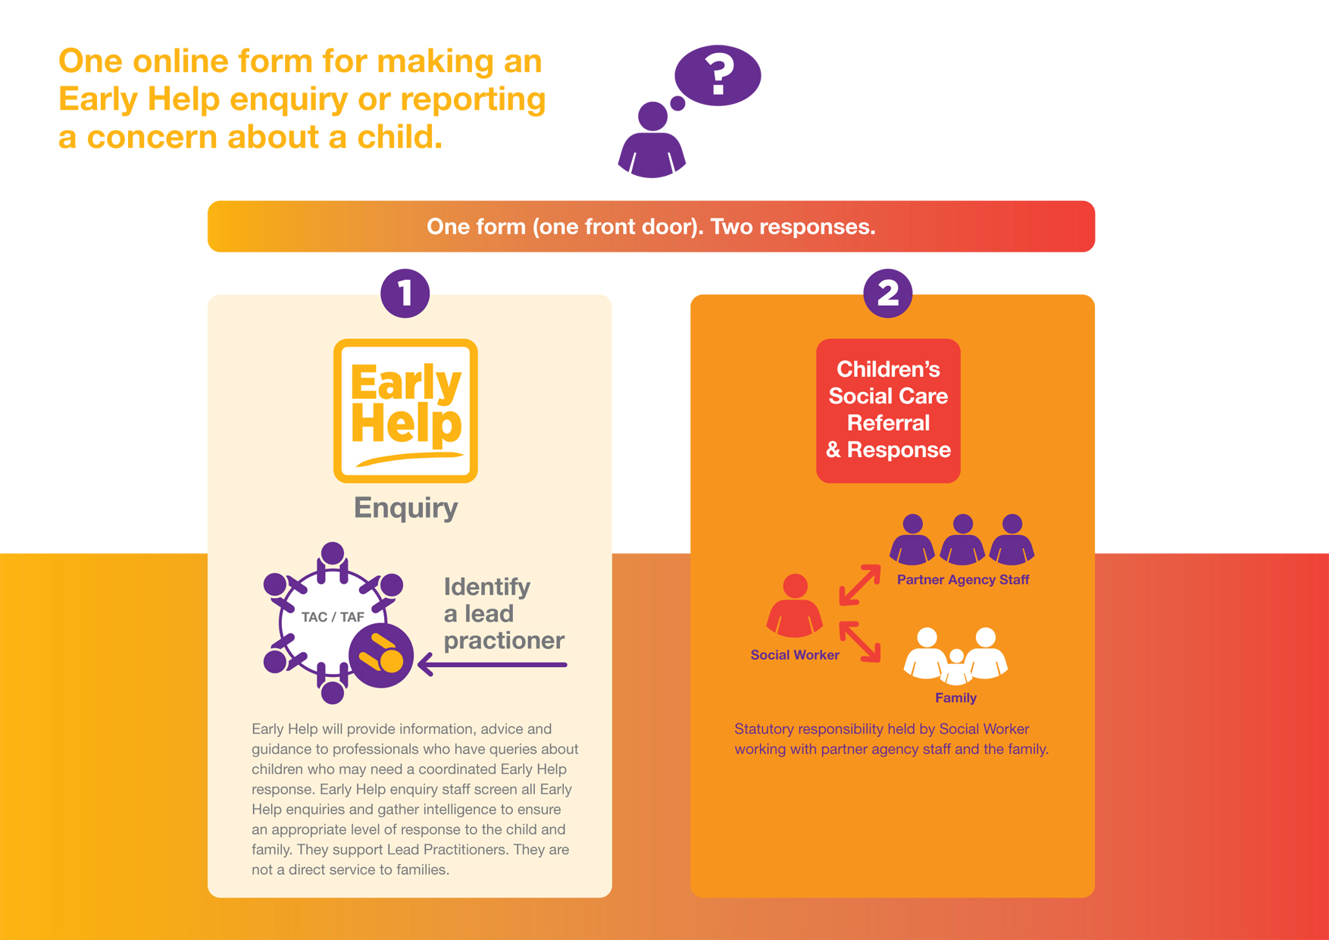

12. Multi-Disciplinary Working or Team Around the Child/Family (TAC or TAF)

If the early help assessment identifies that co-ordinated multi-disciplinary support is required to meet the needs of a child, young person or family then this team of practitioners becomes the Team Around the Child/ Family. The parent/carer and TAC/TAF will agree who is best placed to become the Lead Practitioner who will lead the TAC/TAF in developing a plan of action to support the child or young person in context of their family network. This may, for example, include housing officers, teachers or early years workers. The Lead Practitioner is responsible for ensuring that the plans made for the child or young person are fully implemented and to help resolve any difficulties which may arise..

13. Stronger Families

All families who are eligible for Stronger Families support (see eligibility criteria) will have a named lead practitioner and a plan in place. The Stronger Families Programme is not a separate service or team but provides extra resources for families and their workers to help them, including easy access to small amounts of funds, to overcome issues and barriers to engagement or improvement, access to family leisure passes, access to additional capacity ion other services, access to training for workers and initiatives and interventions for families. To provide these extra resources it will always be necessary to record evidence on the achievement of outcomes with families to make Payment-by-results claims to Government. To do this it will be necessary to ensure eligibility is checked and family progress is closely monitored against those criteria.
All families must meet at least two of the following criteria:
1. Parents and children involved in crime or anti-social behaviour.
2. Children who have not been attending school regularly.
3. Children who need help. (CP/CIN, early years, etc.)
4. Adults out of work or at risk of financial exclusion and young people at risk of worklessness.
5. Families affected by domestic violence and abuse.
6. Parents and children with a range of health problems.

The full Stronger Families Outcomes Plan and much more information is available on the DMBC website or by following the link below:
http://www.doncaster.gov.uk/services/schools/what-is-stronger-families

14. Eligibility for Children’s Social Care

The Children Act 1989 places a duty on the Local Authority to “safeguard and promote the welfare of children within their area who are in need and so far as is consistent with their welfare, promote the upbringing of children by their families by providing a range and level of services to meet their needs”. In Doncaster this responsibility is delegated to Doncaster Children’s Services Trust (in so far as it relates to some CIN who may be at risk of harm or impairment) and specifically CA duties in relation to children at risk at harm or LAC.

The Children Act 1989 defines a ‘Child in Need’ as:

- A child who is unlikely to achieve or maintain, or have opportunity of achieving or maintaining, a reasonable standard of health or development without the provision of services by a local authority;

- A child whose health or development is likely to be significantly impaired or further impaired, without the provision of services;

- A child who has a substantial and permanent disability.

These are not clear-cut definitions and allow room for discussion and professional judgement about the level of need and the associated risk.

Advice on thresholds, Early Help Assessments and Team around the child/family meetings can be accessed through the Early Help Hub.

The attached multi-agency Needs/Risks Matrix – Appendix 1 has been developed to help inform decision making about the thresholds to the four levels of need descriptors and what service children and young people might receive.

The content of the levels has been developed taking into account the learning from local and national serious case reviews, good practice and other case reviews and audits as well as the needs of the local population.

All children receiving a service at level 4 Safeguarding from Doncaster Children’s Services Trust will have a clear plan in place, whether this is a ‘Child in Need’ plan, child protection plan, Looked After Children (LAC) plan or a plan specific to their circumstances. In these situations the social worker is always the lead practitioner. All ‘Child in Need’ plans will be monitored and reviewed at least every six months.

Supporting documentation

This document should be read in conjunction with the following documents which can all be found on the DSCB website:

http://www.dscb.co.uk/

Multi-agency Early Help Strategy for Children, Young People and their Families
The Early Help Practice Handbook
The DSCB Neglect Strategy
The DSCB Neglect Tool

Level 1: Universal
Appendix 1:
Description | Examples of what you might see | Action to take | Desired outcome
Children and young people living in families whose needs are being met or whose additional needs can be met by universal services  Universal services include:  - Antenatal support via midwifery  - New baby support via Health Visitor  - Baby groups, “stay and play” groups etc  - Early Years Library  - Child-minder support and advice on childcare  - Advice on benefits  - Advice on school enrolment  - Schools and out of school provision  - School Nursing  - General Practitioners and other universal health services  - Neighbourhood policing and Communities Area Teams (safer neighbourhood team function)  - Communities Well Being support  - Jobcentre Plus | The indicators listed below are examples only and not intended to be a comprehensive list. The indicators can never replace professional judgement and analysis.  These children, young people and families have no additional needs other than those which are met by universal services for example such as health or education providers.  This includes:  - Immunisation & vaccination  - Routine health visiting services  - Accommodation and rehousing needs  - Positive youth activities  - Targeted diversionary activities and projects in areas  - Neighbourhood policing and Communities Area Teams (Safer Neighbourhood Team function)  - Supporting the community witccident prevention initiatives, healthy eating and obesity  - Supporting the community to provide cleaner, safer neighbourhoods  - Providing help to find young people and parents employment and support into pathway to work  - Providing community participation and volunteering opportunities  - Children and young people who are NEET or at risk of becoming NEET | At this level needs are met by parents, carers and communities and by universal services.  Parents can access ‘self-help’ support and advice through a range of settings such as Children’s Centres, Schools libraries and on line.  Routine surveillance should include awareness of emerging needs, in particular signs of neglect, and the importance of discussing these with the child, parents or colleagues.  Consideration should be given to using the Doncaster neglect tool to ensure neglect is not an issue.  Stronger Families eligibility should be checked to ensure help is given at the earliest point. | Children and young people are:  - Physically, emotionally and sexually healthy  - Looked after by parents or carers who promote healthy and safe choices  - Not affected by avoidable hospital admissions as a result of poor health or accidents etc  - Safe from abuse, neglect and exploitation  - Ready for school and able to attend and enjoy school and achieve educational milestones  - Achieve developmental milestones in accordance with their potential ability  - Are ready to participate in appropriate employment, education or training after leaving school  - Safe from bullying, maltreatment, exploitation, discrimination & non-accidental injury  - Safe from criminal or anti-social behaviour and do not take part in it either  - Confident and taking part in leisure, sporting and social opportunities  Parents:  - Provide a safe, supportive home  - Provide age appropriate boundaries  - Promote healthy life-style choices  - Promote pro-social behaviour

Level 2: Universal Plus
Description | Examples of what you might see | Action to take | Desired outcome
Children and young people living in families who need extra support by taking a more planned approach. Generally this will be through a single agency but it may require services to enlist the services of another agency to meet the families needs. Work will be to be time-limited to support families to become self-reliant again. | The indicators listed below are examples only and not intended to be a comprehensive list. The indicators can never replace professional judgement and analysis.  - Children and young people with emerging health or developmental problems for example relating to diet and nutrition, dental health etc  - Children and young people with isolated or unsupported carers  - Children and young people who need support due to mental or physical health difficulties  - Children and young people requiring additional educational support e.g. behaviour, emotional or social difficulties  - Children and young people with permanent disabilities who require support to access services  - Children and young people who live in households where there has been parental conflict  - Young people who need support or advice in relation to housing  - Young people who are starting to experiment with substances  - Children and young people who have parents/carers in custody  - Children and young people who are involved in anti-social or nuisance behaviour in their communities  - Supporting the community to reduce and tackle anti-social behaviour e.g. using a range of early intervention and prevention initiatives and the new ASB Crime and policing act 2014  - Children whose parents/carers need support to deal with low level domestic conflict or substance misuse  - Children whose parents/carers are struggling to manage their behaviour  - Children whose parents/carers need support to maintain school attendance  - Children whose parents or carers are affected by low level mental, physical or learning difficulties  - Children whose parents/carers need support with finances in order to meet their needs  - Children whose parents/carers who need support to improve hygiene or safety in the home | Use the Early Help enquiry form as a means of identifying the potential level of need.  Professionals make an Early Help Enquiry into the Early Help Hub. Professional support and advice about thresholds can be accessed through the Hub and the locality based Early Help Coordinators.  Stronger Families criteria to be checked.  Where neglect may be an emerging issue workers should use the Doncaster Neglect tool to inform their assessment.  A child and their family’s needs may be met by an existing service offering extra support within its own remit or by signposting or asking another service including:  - Health Visiting support  - Speech and Language services  - Children’s Centres Universal Offer  - Extra learning support  - Money and debt advice  - Family learning  - Help to find work  - 1:1 family support and home visits  - Healthy and wellbeing support for example Healthy weight management, smoking cessation etc  - Substance and alcohol support  - Neighbourhood policing and Communities area team (safer neighbourhood team function)  - Adult support services | The overall outcome from activity at Level 2 is that the child and family are provided with appropriate support to enable them to continue to be supported by ‘universal’ community based services without further need for targeted or specialist service support.

Level 3: Partnership Response
Description | Examples of what you might see | Action to take | Desired outcome
Children and young people living in families who need multi-agency support to meet their needs coordinated by a lead practitioner model.  If an authority determines following assessment that a disabled child needs support under Section 17, it must first consider whether such support is of the type outlined in Section 2 of the Chronically Sick and Disabled Persons Act (CSDPA) 1970.  Where there is an EHC needs assessment, it should be a holistic assessment of the child or young person’s education, health and social care needs. EHC needs assessments should be combined with social care assessments under section 17 of the Children’s Act 1989 where appropriate.  If services are to be provided following an assessment there should be a ‘child in need plan’ which sets out who is going to do what, where and when to help the child. | The indicators listed below are examples only and not intended to be a comprehensive list. The indicators can never replace professional judgement and analysis.  - Children and young people with multiple Level 2 indicators  - Children and young people with increasingly severe behavioural, emotional and social difficulties  - Children and young people with prolonged or acute absence from school  - Children and young people who are at immediate risk of becoming homeless  - Children who have previously been subject to a Child in Need or Child Protections Plan and whose parents need support to help them sustain progress over a planned period  - Children and young people who are consistently not accessing universal services and are therefore “invisible” to agencies  - Children and young people whose health is being potentially impaired as a result of not attending health appointments or complying with treatment plans  - Children and young people whose parents are unable to meet their basic needs as a result of extreme poverty  - Children and young people whose parents are receiving support and treatment who need coordinated support to meet their child’s needs due to the effects of their alcohol or drug misuse  - Children and young people whose parents need coordinated support to meet their child’s needs due to their illness, mental health or learning difficulty or disability  - Children and young people who are at risk of becoming involved with crime or anti-social behaviour  - Children, young people who or whose parents have frequent neighbour disputes or are reported for nuisance behaviour ASB or issues regarding physical conditions of their home  - Children, young people who or whose parents are victims of ASB and crime including racial abuse or other hate crime | Professionals make an Early Help Enquiry into the Early Help Hub. Professional support and advice about thresholds can be accessed through the Hub and the locality based Early Help Coordinators.  The Early Help Hub will screen the enquiry and agree a lead practitioner to coordinate the Early Help Assessment, undertake a TAC/TAF and establish a holistic plan for the family that is aimed at reducing the level of need.  Using the Doncaster Neglect tool will assist in identifying the family’s needs and should be undertaken to ensure neglect is not an issue.  The Doncaster Risk & Resilience Frameworks and similar tools can support the measurement of changes in risk and resilience. These are embedded within the Early Help Module.  Child & Family Assessment tools and techniques (over 200 people trained across partners.  Stronger Families eligibility to be checked | The overall outcome is that the child and family gain resilience and are enabled to be safely supported by the provision of early help and prevention or supported and thrive through universal provision following the early help support.

Level 4: Safeguarding
Description | Examples of what you might see | Action to take | Desired outcome
Children and young people living in families and other settings who are in need of support and/services whose health or development is likely to be significantly impaired or further impaired or have suffered or are likely to suffer significant harm as a result of abuse, neglect or exploitation.  Children and young people who have a substantial and permanent disability whose health or development is likely to be significantly impaired or further impaired unless services are provided.  Children who require a statutory intervention as a result of offending.  Children who have acute mental health needs requiring treatment | The indicators listed below are examples only and not intended to be a comprehensive list. The indicators can never replace professional judgement and analysis.  Examples could include:  - Children or families who display multiple Level 2 or 3 indicators in combination  - Children and young people who have suffered or are likely to suffer significant harm as a result of sexual, physical or emotional abuse by an adult or a child  - Children and young people whose behaviour presents a serious risk to themselves or others  - Children or young people who need respite care or intensive support packages due to complex disability or health issues  - Children and young who are at risk of significant harm due to substance misuse issues  - Children and young people who have suffered or are likely to suffer significant harm due to sexual exploitation or violence within a relationship  - Children and young people with chronic ill health or life-limiting conditions  - All children and young people assessed as having an underlying mental health disorder and who are receiving treatment  - Children and young people whose parents/carers are unable to provide care due to the effects of their alcohol or drug misuse where evidence suggests the child is at immediate risk of or is suffering from significant harm. NB these could include unborn babies  - Children and young people whose parents/carers are unable to provide care due to domestic abuse where evidence suggests the child is at immediate risk of or is suffering from significant harm NB these could include unborn babies  - Children and young people whose parents/carers are unable to provide care due to the effects of their own mental health or learning disability; where evidence suggests the child is at immediate risk of or is suffering from significant harm. NB these could include unborn babies  - Children and young people who have entered the criminal justice system  - Children and young people who have been adopted and who or whose adopters are assessed as needing support  - Children and young people who are privately fostered  - Young people aged 16 and 17 who are homeless and require the council to provide accommodation  - Children who present a risk of serious harm to themselves or others  - Children and young people who are not able to live at home due to complex, life threatening or terminal illnesses  - Children who have been hospitalised due to a mental health issue | These children are likely to require a statutory intervention from children’s social care services or if they have entered the criminal justice system, from the YOS or if they are not attending school education welfare services or medical intervention including hospital admissions.  At this level a referral must be made to DCST Referral and Response Team which is accessed in the same way as the Early Help Hub.  The Doncaster Neglect Tool should be used to ensure an accurate assessment of neglect.  Children and young people will require coordinated services from specific agencies including: DCST, DMBC SY Police, RDaSH and DBHFT. They may be subject to Child Protection or Care Plans and may live in alternative settings including fostering, residential, custodial and hospitals.  If you assess a child or young person to be at or continue to be at risk,  dependant on circumstances, actions may include:  - Seeking advice from your agency’s designated worker or child protection lead  - Calling the Police or emergency medical if a child or young person or adult is in immediate danger If a child young person or adult is in immediate danger  - If you feel a child has suffered or is at risk of significant harm you have a duty to refer to the DCST the Referral and Response  When you are referring to the Referral and Response Team you must provide information about the previous support that has been provided to the family and the involvement of your or other agencies.  A telephone or email referral should be followed up in writing within 48 hours and the DCST will provide you with information regarding their actions and the outcome of your referral.  There are other opportunities to share concerns about future risk of harm to a child, including MARAC and MAPPA serious crime and domestic abuse meetings and the DCST. | The overall outcomes from activity at this level of assessed need is to mitigate and reduce the level of risk to the child so they are no longer likely to suffer significant harm.  Having assessed the child’s ongoing and future needs in most circumstances it is expected that support will be “stepped down” to lower levels of provision to help the the family to maintain the progress that has been made.  In some cases where this is not possible the outcome is likely to be that alternative arrangements are made for the care of the child for example with family members or within the Looked After Children system

