Doncaster Safeguarding Children Partnership
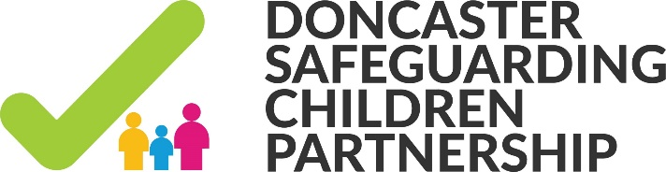

Tel:
Fax:
Episode Record
Details of
Family Name | Richards |  | Given Names |  |  |  | Tom, Ricky, Leo, Charley. Kia and Donna
Actual DOB | Tom 21.02.2001  Ricky 03.04.2002  Leo 22.12. 2003  Charley 16.06.2007  Kia 08.07.2008  Donna 04.03.2015 |  | Gender |  |  |  | Male  Male  Male  Female  Female  Female
Ethnicity | White British |  | Primary Language |  |  |  | English
Primary Address | 1 Sunbeam Road  Doncaster |  | Telephone
 |  |  | Mobile |  |  |  | 0700 0000000
Outcomes Star
Type of Star
Closure Record
Closure Start Date Details
Start Date of Episode |  |  |  | 06.01.2016
Date Closure Record Started |  |  |  | 15.06.2016
Closure End Date Details
End Date of Episode |  |  |  | 15.06.2016
Closure Issues
Presenting Issue/s |  |  |  | Crime, ASB, Parental substance misuse, housing and tenancy issues, low school attendance
Primary Prenenting Issue |  |  |  | Parental substance misuse
Closure Analysis
End Reason |  |  |  | Outcomes met
In your professional view, how effective has the family plan been in improving life for this child / young person and family
Parents / Carers Views
How effective has the Family Plan been for the child / young person in improving their life
What are the next steps that need to be / are being taken for this child / family
Success Rating |  |  |  | 1 2 3 4 5 (5 being very succesful)
Rationale for Success Rating Chosen
Final Stronger Families Eligibility Checklist
1. Parents and children involved in crime or antis-social behaviour |  |  |  |  | Yes No
Give Reasons
2. Children who have not been attending school regularly |  |  |  |  | Yes No
Give Reasons
3. Children who need help |  |  |  |  | Yes No
Give Reasons
4. Adults out of work or at risk of financial exclusion or young people at risk of worklessness |  |  |  |  | Yes No
Give Reasons
5. Families affected by Domestic Abuse |  |  |  |  | Yes No
Give Reasons
6. Parents and children with a range of health issues |  |  |  |  | Yes No
Give Reasons
Has the Area FIO been informed |  |  |  |  | Yes No
Overall Level of Need
Overall Level of Need |  |  |  |  | Universal Universal Plus Partnership Safeguarding
Manager Authorisation
Managers Rationale
Attaschments (0)
Recorded Feedback
The completed Episode should be discussed with the child/young person and their parents/carers
Person |  | Discussed |  |  | If no, when | Given |  | If no, when

