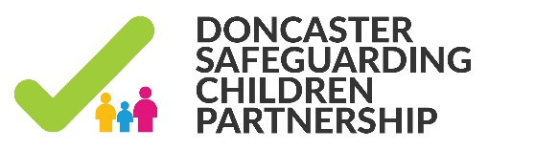

PRACTICE briefing
Learning Lessons Review - Child M

Case Summary:
The DSCP agreed to undertake a Lessons Learned Review in respect of Child M following South Yorkshire Police escalating concerns regarding the large number of times Child M went missing after returning to Doncaster from secure accommodation. The brief circumstances of the specific incident are that Child M absconded and was then caught up in a violent incident involving organised crime members and where weapons were reported as being used. The LLR was undertaken using the Welsh Methodology which includes facilitating a practitioner event.

There were a number of specific lessons relating to how time spent in secure placement could be used to effectively plan for a child. There were also learning points around the effective use of psychological assessments for children who had suffered family breakdown; history in care or history of abuse. There were further lessons in relation to care planning including ensuring that the young person understands the long term goal and also the difficulties arising from numerous placement changes and the numerous care givers this leads to.

Poly-Victimisation and the Impact on Risk:
It was apparent from the LLR that Child M had experienced multiple placements and placement breakdowns in spite of significant efforts from a number of professionals from a range of backgrounds and within different levels of the organisation. One of the most significant learning points from this appears to be how difficult it can be to engage with teenagers particularly those who as Finlklehor has identified have experienced poly-victimisation. In Finlklehor 2007 paper “Poly-victimisation: A neglected component in child victimisation” he identifies up until that point most literature had focussed on the effects of specific individual kinds of victimisation such as sexual abuse. Finlkehor goes on to argue that most such studies have failed to obtain complete victimisation profiles. This creates the potential for several kinds of problems particularly if children who experience one kind of victimisation are at greater risk of experiencing other forms of victimisation. Children appear to be chronically targeted year after year. Multiple victimisations are more likely to be “symptoms” rather than the actual “cause” of the problem.

It was clear from the review that Child M had the potential to fall into the category defined as young people who experience four or more forms of abuse in one year. The general concern arising from this is that in the Triennial Analysis of Serious Case Reviews Brandon identifies Pattern of serious case reviews over time shows that once a child is known to be in need of protection, for example with a child protection plan in place, the system is working well. There has been no change in the number of child deaths linked directly to maltreatment and, if anything, a reduction in the fatality rates for all but the older adolescent age group.
By adolescence the impact of long-standing abuse or neglect may present in behaviours which place the young person at increased risk of harm. Almost two thirds of the young people aged 11-15, and 88% of the older adolescents, had mental health problems. Some young people responded to adversity by engaging in risk-taking behaviour including drug and alcohol misuse and offending. There is cumulative risk of harm to a child when different parental and environmental risk factors are present in combination or over periods of time. In common with Child M Brandon identifies absconding as a particularly significant risk factor.

Ben Brown, DSCP Development Manager
May 2020

