Signs of Neglect for Young People

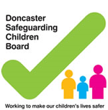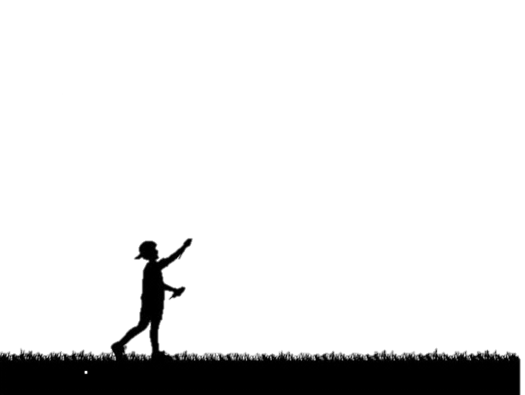

Your parents/ carers may be ill

**WHY MIGHT YOU BECOME NEGLECTED?**

Your carers may have drug/alcohol problems.

**NEGLECT IN DONCASTER**

Aren’t protected from dangerous situations.

You may suffer from mental health illnesses

You may get into trouble at school.

**WHAT CAN HAPPEN WHEN YOU ARE NEGLECTED**

The Doncaster safeguarding children board has a ‘neglect strategy’ in place to identify neglect in the earliest possible stage.

**SIGNS TO LOOK OUT FOR..**

**WHEN CHILDREN ARE NEGLECTED THEY:**

Don’t have a safe place to live

Are being left alone often.

If you or another child needs help, contact: **01302 737777**

Find out more by visiting[**www.dscb.co.uk**](http://www.dscb.co.uk)or[**www.doncaster.gov.uk**](http://www.doncaster.gov.uk)

In 2015, 72% of ‘Child In Need, cases were liked to abuse/neglect

Poor communication skills

Trying to get attention from others

Seeming hungry or tired.

Having no friends and being alone a lot.

Don’t have clean/warm clothing

Your parent/carer may be in a violent relationship.

Your carers don’t have any support which they may need.

You may harm yourself.

You may struggle to build relationships