Data Protection and Appropriate use of Mosaic Case Recording System

What is Mosaic?
Mosaic is the name of the integrated case management system commissioned by City of Doncaster Council for use by staff and partner organisations. Doncaster Integrated Peoples Solutions team within Doncaster Council are responsible for hosting the system.
A strength about Mosaic is that it is integrated, pulling information from Early Help plus Adult and Childrens Social Care. An integrated system makes sure there is one point of information about a child or family and prevents duplication and when used well can aid appropriate information sharing with partners.
Almost all families will have consented for their information to be recorded within Mosaic and how this information will be used. Where families have not consented to these records being kept it is because the level of safeguarding need overrides consent.
All internal and external practitioners wishing to access Mosaic must be trained in working with children and families and appropriate use of Mosaic.

Data Protection Act 2018 and Consent
The Data Protection Act, 2018, controls how your personal information is used by organisations, businesses or the government.
Mosaic contains sensitive personal data, everyone responsible for using personal data has to follow strict rules called ‘data protection principles’. They must make sure the information is:
- used fairly, lawfully and transparently
- used for specified, explicit purposes
- used in a way that is adequate, relevant and limited to only what is necessary
- accurate and, where necessary, kept up to date
- kept for no longer than is necessary
- handled in a way that ensures appropriate security, including protection against unlawful or unauthorised processing, access, loss, destruction or damage

The Data Protection Act, 2018, makes clear the use of data must be necessary, proportionate and relevant. This means everyone with access to Mosaic must ensure they fully apply these principles every time they use Mosaic.

When a family gives consent for their data to be recorded within Mosaic, they do so in the knowledge their personal data will be kept safe, used for specific purposes and accessed only when necessary, proportionate and relevant to the circumstances.
To remind Mosaic users of these principles we have updated the Data Protection Statement within Mosaic.
It is possible to identify anyone who accesses a child’s case file, checks occur at random intervals but also at any time concerns are raised. Accessing a child’s case file without a legitimate professional reason is a serious matter, it could lead to disciplinary action within your own organisation and prosecution.

How to use Mosaic Appropriately:
Mosaic has permission levels of access to protect practitioners from accessing restricted sensitive personal information. Although Early Help practitioners can only see Early Help information it is still important they apply the Data Protection Act, 2018, principles to this.
If you are worried about a child it is important to talk to their family about this and offer help. It is appropriate to access the child’s basic summary page within Mosaic to check if the family are already receiving help; this should only be done after speaking with the family and trying to gain this information from them. From the summary page the name of the Lead Practitioner or Social Worker and form being completed is clearly visible. If you need this workers contact details make contact with Early Help Coordinator team or Social Worker Duty worker. It is important that you do not access any further into the case file as you do not have permission to do so.
Early Help Coordinator Team | 01302 736250
Social Care Central | 01302 736543
Social Care East | 01302 735979
Social Care North | 01302 735465
Social Care South | 01302 736411
Social Care Assessment | 01302 735208
Social Care Children in Care | 01302 735052
Social Care IFT  (care leavers) | 01302 737559

If there is no named Lead Practitioner or Social Worker the child and family are not currently receiving help, you should not access any further into the case file. You should talk again to the family about your worries and seek their consent for help following DSCP guidance; Early Help in Doncaster-an introduction, and Multi-Agency Thresholds training is available through: https://buy.doncaster.gov.uk/training
It is appropriate for a Lead Practitioner and Team Around the Family members for a child and family to access the full Early Help case file; Assessments, Team Around the Family Review Meetings, Direct Work forms, documents and case notes, as consent will be gained for this via the consent form. This will enable efficient information sharing and ensure the case file evidences the work of each Team Around the Family member.
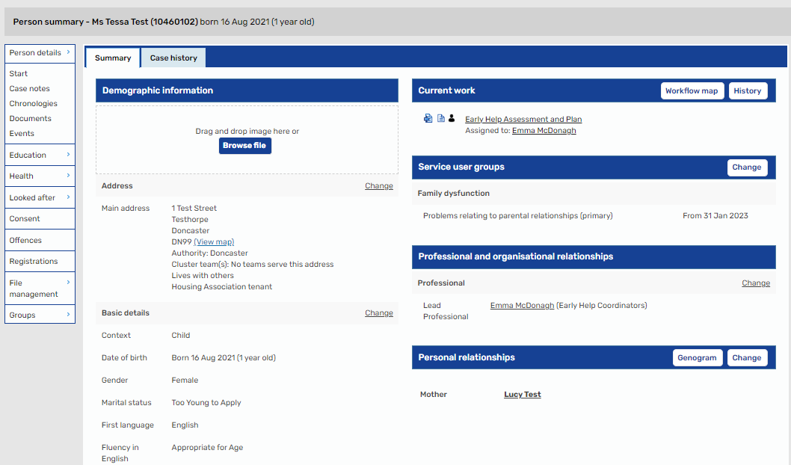
This child is receiving Early Help, her Lead Practitioner is Emma McDonagh

If you are unsure about whether a child is already receiving help, who their Lead Practitioner or Social Worker is, or their contact details make contact with the Early Help Coordinator Duty Line: 01302 736250. Early Help Coordinators can also give advice about talking to families about worries and offering help; and guidance on Thresholds of need.

Subject Access Requests
Children and their families have the right to access information held by organisations about them; this is known as a Subject Access Request; we are required by law to share this information with them. Some Subject Access requests are made whilst services are working with the family, others come much later. It is important that everyone recording within Mosaic bears in mind these records may be seen by the child, young person or family.

What you must not do:
- Record anything that is personal opinion
- Record anything that is not factual
- Access any case records without a legitimate professional reason for doing so and have the evidence for this
- Access case records beyond the person summary page without family consent

What should do:
- When writing your professional opinion, always make clear this is your professional opinion and not a fact.
- Be balanced and solution focused in your record keeping.
- Gain and upload families signed Early Help consent form into Mosaic as a document.
- Contact the family’s Lead Practitioner or Social Worker to ask to join the Team Around the Family, Child in Need or Core Group meetings.
- Contact the family’s Lead Practitioner or Social Worker to share or request updates.

No Response
It can feel frustrating when practitioners don’t reply to us is the timeframe we expect; this can be for lots of reasons such as absence from work, or safeguarding priorities. Do not be tempted to go beyond the child’s Mosaic summary page, make contact with the Early Help Coordinator team who will provide you with the Lead Practitioners manager contact details; and if appropriate intervene on your behalf to ensure effective communication.

